**Assignment 5**

**Objective** – Power BI Desktop, Cloud Service and End to End Workflow

**Use Case** – Conditional Formatting

**Source** – LTD Sales

**Analytics** – Format as per the condition

**Report/Dashboard** – Sales Range

**Data Loading**

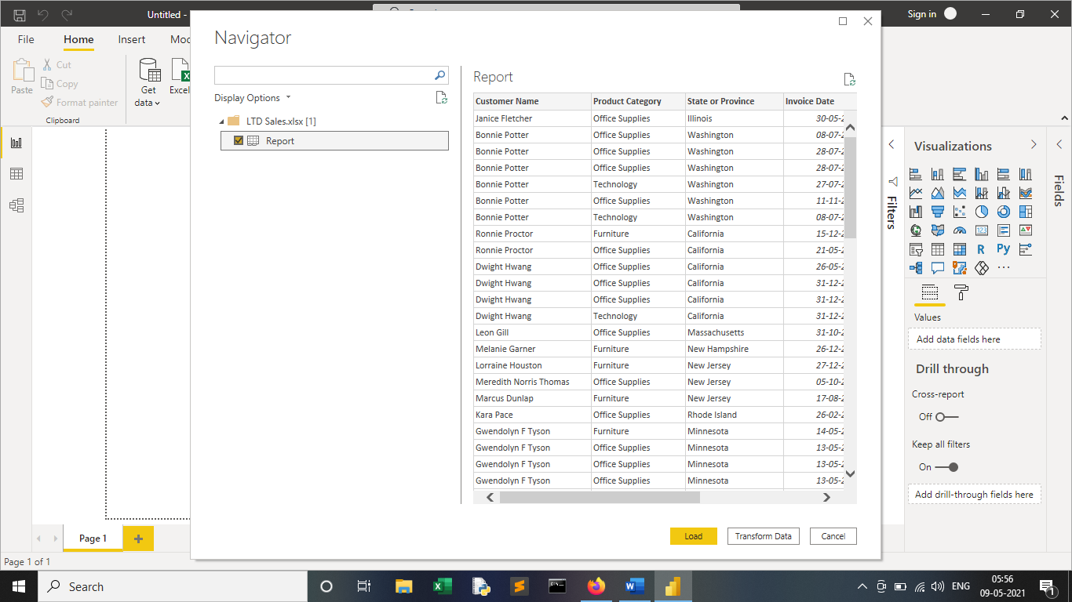

**TASK 1: Need to showcase the Revenue as per the State.**

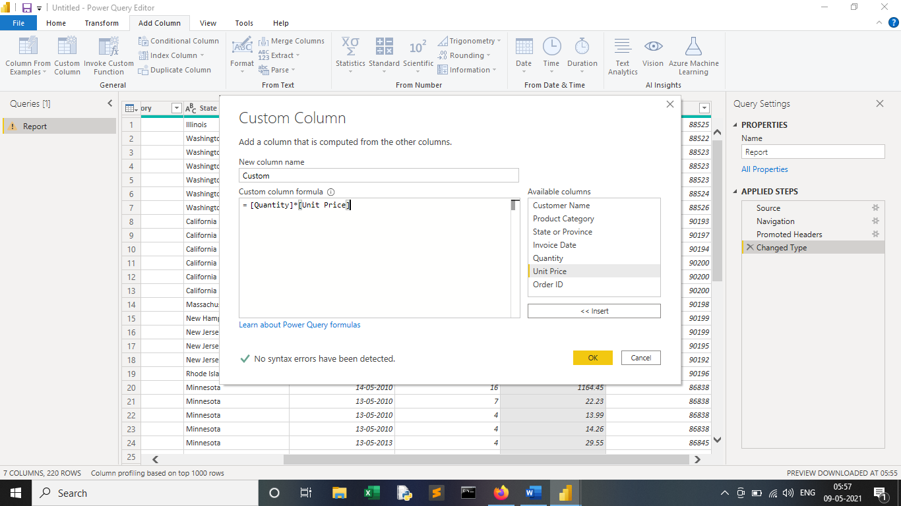

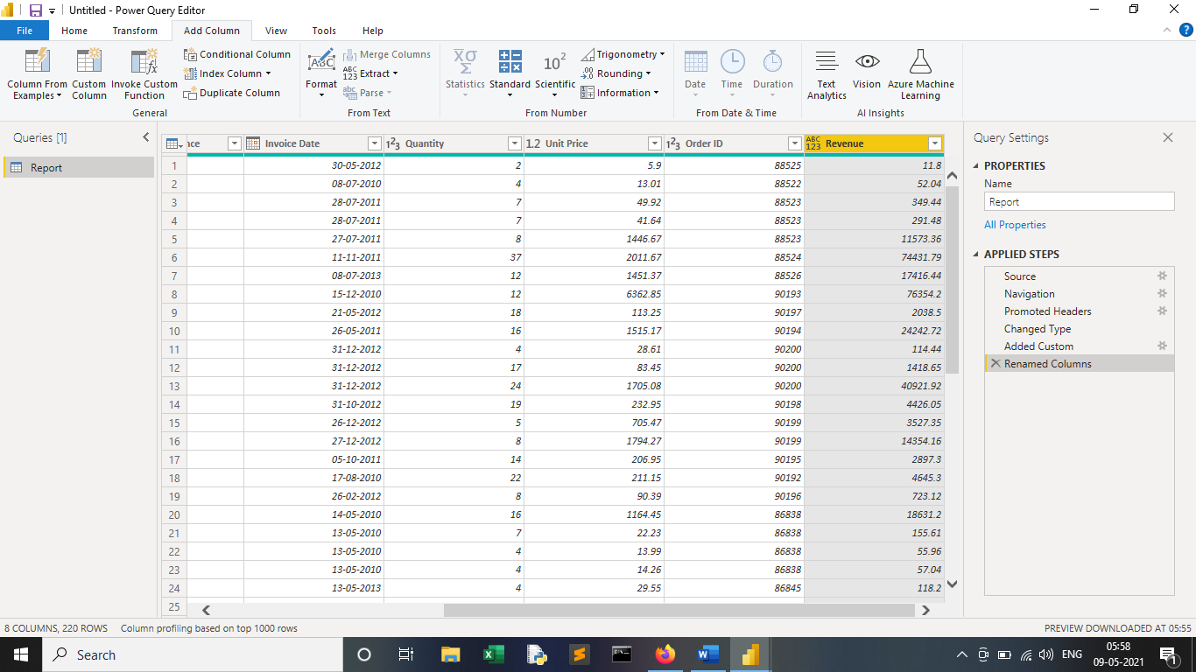

**TASK 2: Create a new column as per following condition as per the sales**

**1. Sales Range**

**2. Less 100**

**3. 1001 to 5000**

**4. 6000 to 10000**

**5. 11000 to 15000**

**6. 16000 to 20000**

**7. 21000 to 25000**

**8. Above 25000**

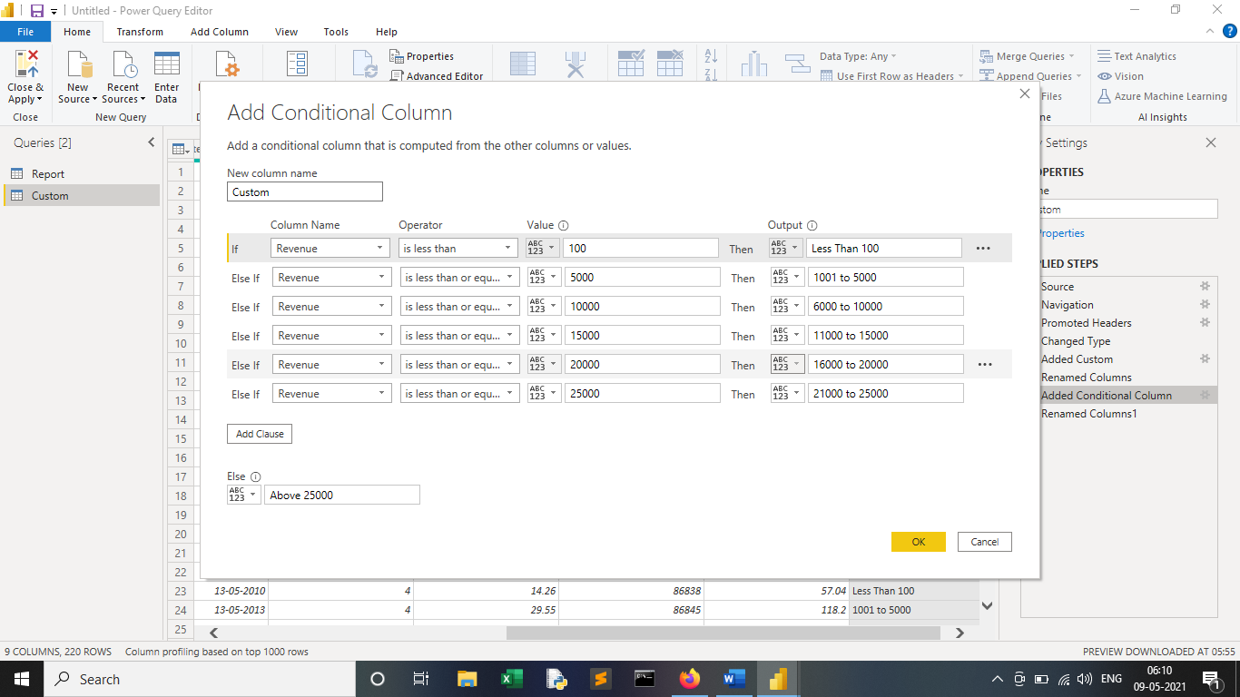

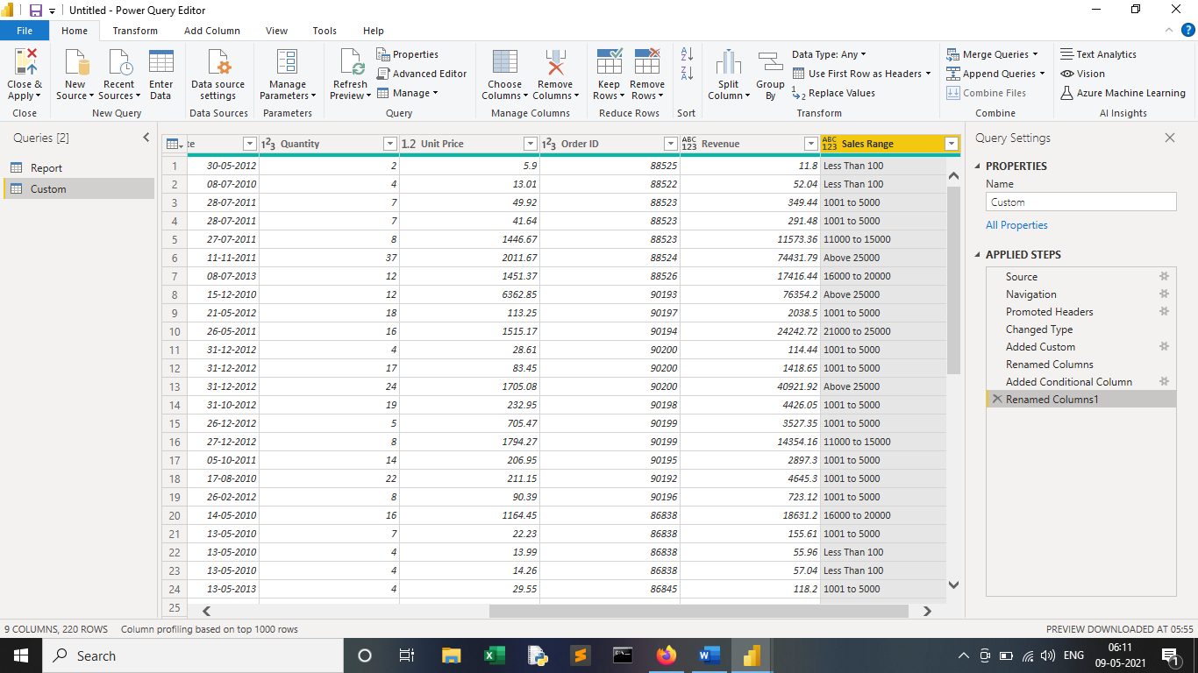

**TASK 3: Create a new column as per following condition as per the Product**

**Category where for: -**

**1. Furniture it should show “Office Infra”**

**2. Others it should show “Non-Office Infra”**

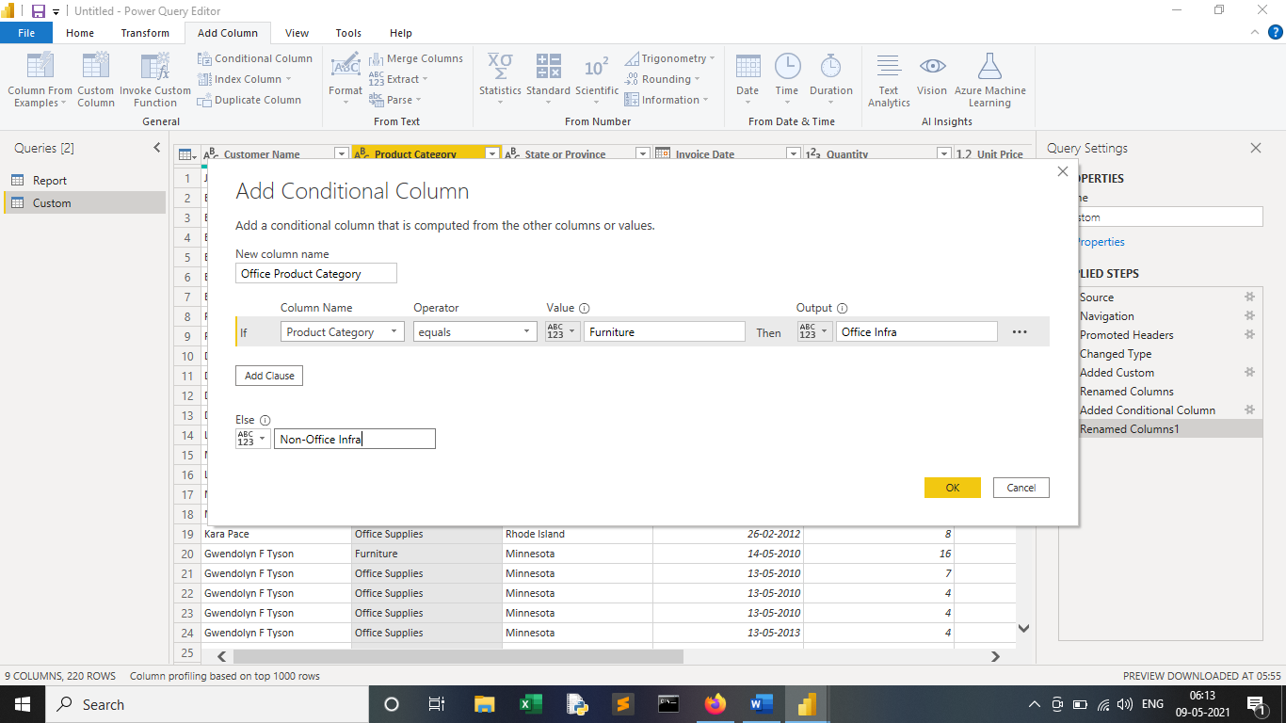

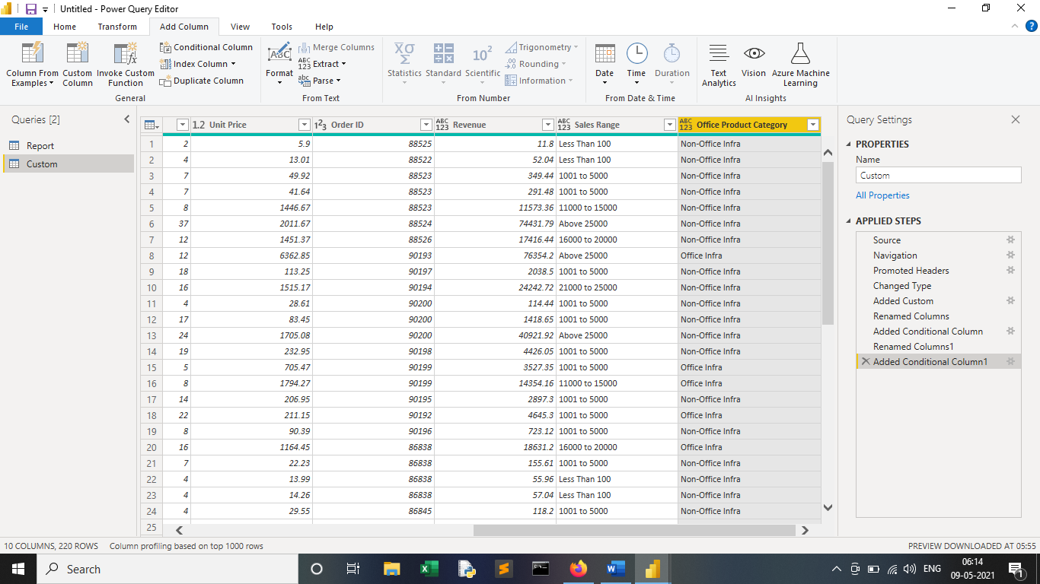

**Dashboard**

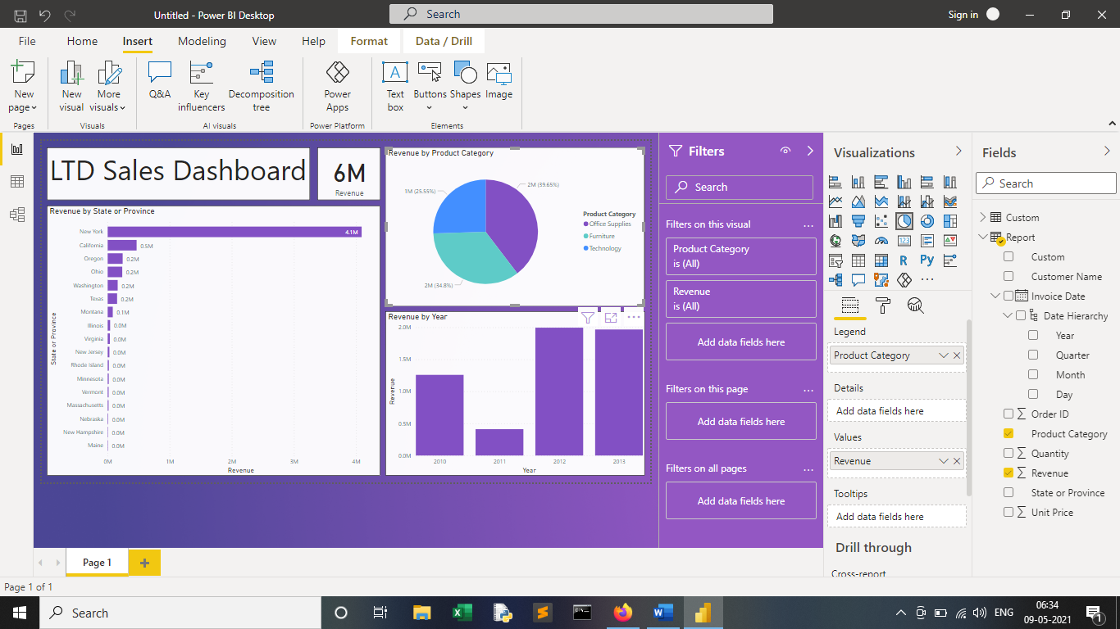

**Conclusion**

In this Assignment of LTD sales, we learn to do Conditional Formatting of column using various conditions in Power Query Editor.

From the above Report Sales Dashboard, we can conclude the following,

* Total Revenue of LTD Sales for the Year of 2010,2011,2012,2013 is 5.63 Million $.
* As per Revenue by State in the 4 Years, "New York" have done the Highest Number of Sales with Net Worth of 4.08 Million $ covering almost *72% of Revenue* of Company in the Entire Country, whereas State "Maine" have done the Lowest Sales Overall of 2.16K $.
* As per Revenue by Product Category in the 4 Years, "Office Supplies" have done the Highest Sales covering almost 39.65% of Revenue, "Furniture" is 2nd in terms of Sales with almost 34.8% of Revenue, whereas "Technology" is the Lowest in terms of Sales covering 25.5% of Revenue.
* As per Sales Revenue by Year, "Year 2012" was the Best Year in Terms of Revenue with Net Worth of almost 2 Million $, whereas "Year 2011" was the Worst Year in Terms of Revenue with Net Worth of almost 0.41 Million $.